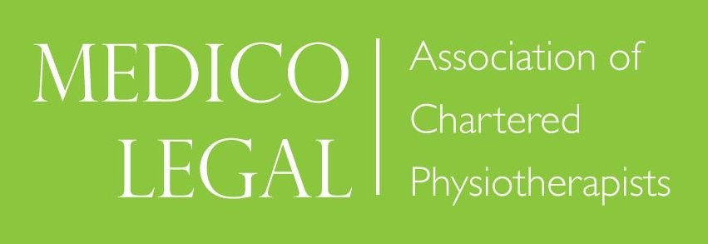

‘AFTER THE REPORT, WHAT’S NEXT?
A guide to case conferences, joint statements and giving evidence at Court

Hosted in conjunction with
Irwin Mitchell Solicitors, One St Peter’s Square, Manchester, M2 3AF

Friday 24th April 2026

09.00 – 09.15 Introduction by Course Leader

09.15 – 10.15 Medico-legal framework, Timescale, Costing, Where Do You Fit In and How we choose the Expert
Sharon Williams, Partner, Irwin Mitchell

10.15 – 10.45 Case Conference – the Physiotherapist’s aspect
Colette Ingham, Chartered Physiotherapist

10.45 – 11.00 Break

11.00 – 12.30 Practical with audience participation- Case Conference
(based on report supplied)
Reflection and discussion post Case Conference
Introduction by Sharon Williams, Partner, Irwin Mitchell
Chaired and led by Counsel, Darryl Allen

12.30- 13.00 Lunch

13.00 – 14.00 Joint Statements
What is it and why it is important in the legal case?
Includes pre-recorded example of Joint statement meeting
Cathy Wilde, Chartered Physiotherapist

14:00 – 14:30 Joint Statements - Legal Insight
TBC, Solicitor, Irwin Mitchell

14.30 – 14.45 Break

14.45 - 15.15 Preparation for Court Appearance
Tim Edbrooke, Chartered Physiotherapist

15.15 – 16.30 Court Room Skills/ Mock Court
Led by Darryl Allen, Barrister, Byrom Street Chambers &
Sharon Williams, Partner, Irwin Mitchell Solicitors

16.30 Questions

