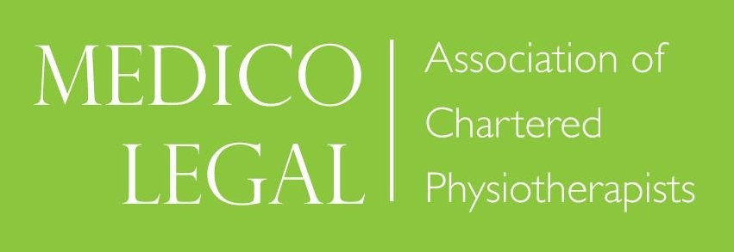

Managing medico-legal work in the time of COVID

An informal online meeting for discussion and support

Wednesday 14th October 2020, 7.30 to 8.30pm

This is a follow up to the successful Zoom meeting held on 14th July 2020. We will be joined again by a personal injury solicitor and the MLACP committee. It will be an opportunity to discuss current issues, difficulties or successes, exchange ideas and share practical tips.

It is open to all MLACP members and is free.

Please send your thoughts or questions by email to:
Lorna Stybelska at stybelskal@aol.com

For details of how to participate in the Zoom call please contact Ginny at info@mlacp.org.uk

