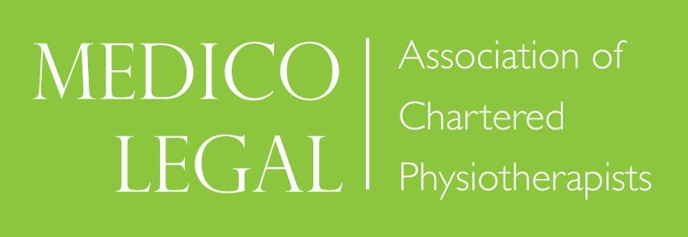

Minutes of the 19th Annual General Meeting of MLACP
9.45am on Friday 18th November 2016

1. Apologies for Absence
Heather Angilley, Pip White (Strategy), Zena Schofield, Muhammad Mabeen
There were 32 member present for the AGM

2. Agreement of Minutes of 18th Annual General Meeting held 13th November 2015
These minutes were agreed as a true record and unanimously adopted, after being proposed by Brian Simpson and seconded by Sue Filson.

3. Matters Arising
There were no matters arising.

4. Annual Reports

4.1 Chair’s Annual Report – Brian Simpson
The chairman's report is on the MLACP website

The Chair’s report was unanimously accepted after being proposed by Sarah Daniels, and seconded by Judith Bentley

4.2 Treasurer’s Report – Susan Filson
The Treasurer’s report is on the MLACP website.
There was a reduction in subscriptions this year, and a reduction in course fees coming in. But last year there was a lot of income as it was an exceptional year for income from courses. Looking at figures from the year before last year, the figures are more or less equivalent.

The website costs had increased this year as the beginning and middle phases of website were undertaken. Approximately £9000 difference in figures from last year was due to this. The payment for implementation of the member’s areas is just about to be taken out, but this was a loss that was budgeted for, as we had the reserves. The reserves have been spent on member services for website.

Capitation fees have not been collected for this year, and will be added on to next year.

The treasurer’s report was unanimously accepted after being proposed by Judith Bentley and seconded by Lorna Stybelska.

4.3 Education Programme Report – Will Winterbotham
WW: Both basic and advanced courses were run this year, with the advanced one in September
Next year the advanced course will have MSK bias, just as this year’s course was biased towards neurological physiotherapy.
The format of the advanced course has been changed slightly, and the course has received good feedback.
Basic course: The introductory course this year was hosted by Withy King at Chandos house. This year it had a MSK focus.

2017:
Next year the basic course will be focused towards neurological physio, and will be in March, 2017.
The 2017 advanced course will run in September/October.
Next year’s AGM will be on the 24th of November at the CSP.
There will also be a courtroom skills course next year, with the venue and date to be confirmed.

Thanks must go to Virginia Daly who is the virtual administrator for the MLACP for all her good work organizing the courses, and Judith Bentley also asked for the efforts of Lorna Stybelska to be acknowledged for the effort she has put into preparing for the AGM.
The aim for the annual conference was that it had an across the board appeal so that all members will be able to get something out of it.

The Education report was unanimously accepted after being proposed by Sarah Daniels
And seconded by Carmel Richards.

5. Election & Ratification of Officers
Current Committee:
Brian Simpson (Chairman), Susan Filson (Treasurer), Colette Ingham (Membership Secretary & Public Relations), Cathy Kwan (Minutes Secretary) Lorna Stybelska (Education Programme), Pip White (Strategy), Sarah Daniel (Website), Will Winterbotham (Assistant Education Programme), Rob Swire (Diversity Officer). Kate Sheehy (Vice-Chair), Judith Bentley. [Virginia Daly Co-opted Virtual Administrator]
No changes.
Thanks to the committee were given by the Chairman. The committee was unanimously approved after being proposed by Pamela Simpson and seconded by Alison Feddeli.

6. Strategy: Pip White
The strategy of the network is available on the website.

Pip White prepared a statement, delivered by Cathy Kwan:

“We have pursued at busy period of work over the last two years and have completed the first cycle of our two year strategy plans. Following a clear strategy has enabled the Executive to focus our work towards what we believe members expect from us. We have continued to deliver high quality course for members and have delivered the long awaited new website as a key resource for members.

The Executive believes that the current strategic focus of the network is right and is working so far. This means that we believe we should continue with the main strategic direction of the network over the next two-year cycle. This mean many objectives remain the same, and where they do we will continue to build and refine the work we deliver to improve our services to you.”

The strategy report was unanimously accepted after being proposed by Lorna Stybelska
And seconded by Kate Sheehy

7. Website Update: Sarah Daniel

The website has been completely redone. The platform of the original website needed to be rebuilt, as it couldn't be found in searches. The search function of members was difficult to navigate and didn't work.

The background and functionality of the site is now automated, which means online application for membership and online payment is now working and is running smoothly.
From Jan - now the committee have been pulling together resources that would be useful and are now available to members in the members only section which is now live. Members need to login to the members only section with a username and password.
In this area there is a whole host of resources including T&C, recent cases, CPR 35, MOJ updates, strategy of the association, etc.
Feedback is welcome with regard to documents or items that would be useful to assist medico legal practice.
The end of the membership year is approaching (next month) so all members should receive automated renewal notice. There will be a second reminder in February, but this won't discriminate between those who have already renewed in Jan, so if you have renewed but receive the second email please ignore it.

We are now looking at providing online payment for courses next year.
Thanks go to the committee for providing resources for the website.

Questions: A question from a member was is it possible to have an area such as a forum? It was explained by Lorna Stybelska and Colette Ingham that there wasn’t one because it needs to be moderated, but the iCSP or LinkedIn networks can fulfill this function.

There is information regarding MedCo on the website. However, in Northern Ireland – MedCo doesn't have any jurisdiction, nor in Scotland. It was pointed out that this needs to be made clear on the website, as physiotherapists from both Scotland and NI have done the MedCo Accreditation training as they saw on MLACP site. Brian Simpson stated the physiotherapists should be reimbursed for any MedCo training. Individual questions can send through to info @mlacp to get specific answers.

The website will be changed to reflect that MedCo is not applicable to NI or Scotland.

Action: SD and PW to clarify things on the website if it does not apply to NI or other areas.

The Website update report was unanimously accepted, after being proposed by Sharon Turl and seconded by Judith Bentley.

8.0 Items brought to the attention of the executive
No other items have been brought to the attention of the committee.

9.0 Date of Next AGM: Friday 24th November 2017

10.0 Close of Meeting 10:15

